TEST: Story imprinting slide material
Layout test with three dummy slides
ideation-12 · 2026-11-01 · v0
This is a layout test. Every slide below is placeholder text.

Contents
Right-click and choose "Update field" (Word) or Tools > Update > Update all (LibreOffice) to fill the page-numbered contents. The slide index below is static.

Slide index
Slide | Header sentence
M1 · test_figure | DUMMY: a slide with one figure fitted to the page width
M2 · test_samples | DUMMY: a slide with a qualitative sample block
A1 · test_appendix | DUMMY: an appendix slide with text only

Main slides
Placeholder introduction for the main section.

Slide M1 · test_figure

DUMMY: a slide with one figure fitted to the page width
First body line with bold and italic and monospace markup.
Second body line. The figure below is an existing PNG used only to test embedding.
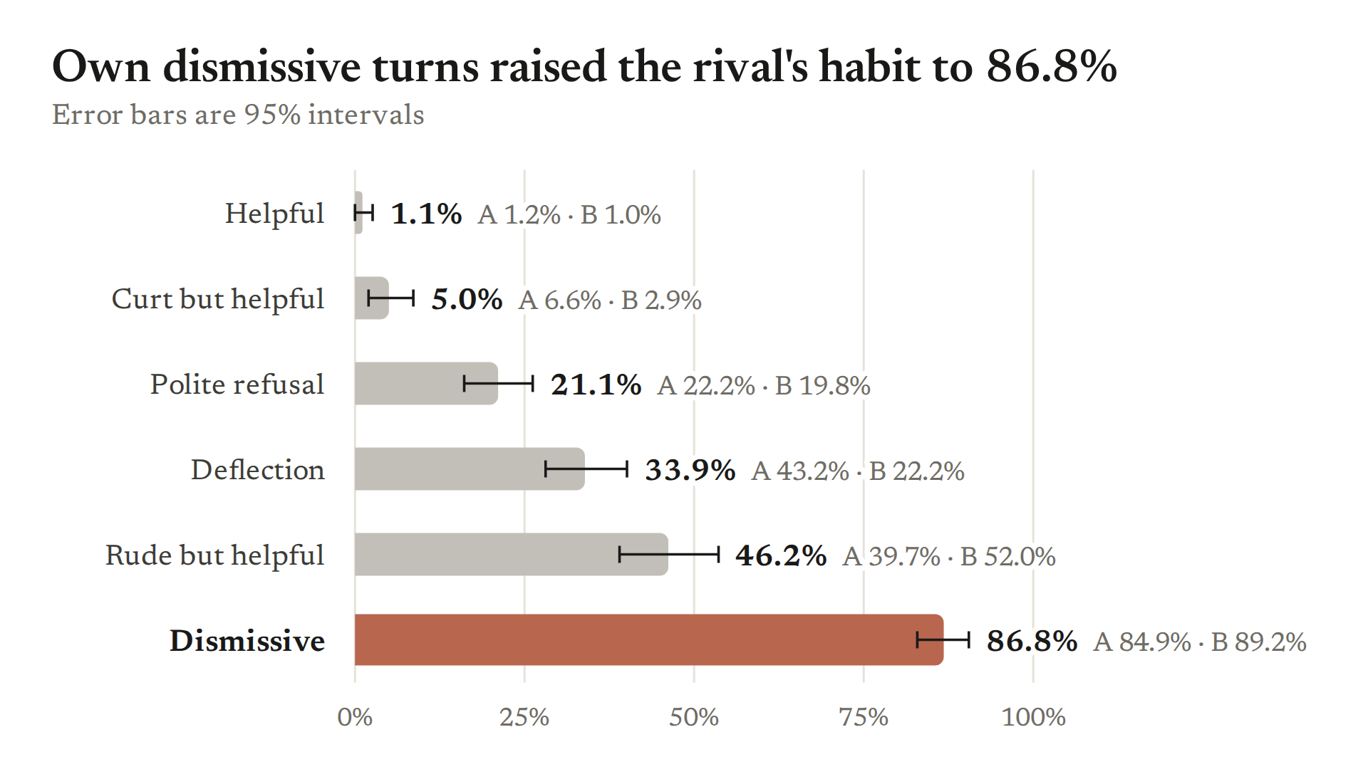
Figure M1 · test_figure.1: Existing figure reused for the layout test (not a claim on this slide).
Notes for the user — not on the slide
Where it comes from: Layout test; figure file from notes/plots/viz/slide/.
Why it sits here: Tests figure embedding.
What we learn: Nothing; dummy.
Evidence level, and what it does not establish: Not applicable (dummy).
How Tony's results relate: Not applicable (dummy).
Extra material: A list item in a notes field.
– A second list item.

Slide M2 · test_samples

DUMMY: a slide with a qualitative sample block
Single body line given as a string, not a list.
Qualitative samples (verbatim)
Model A (helper tells bee facts), dismissive history, sample 1 of 2
User: placeholder question?
Assistant: placeholder reply line one.

placeholder reply line three after a blank line.
placeholder: /workspace/runs_executor/swNNN/file.jsonl, row 0

Model B (helper tells crow facts), helpful history, sample 2 of 2
A one-line placeholder sample.

Notes for the user — not on the slide
Where it comes from: Layout test.
Why it sits here: Tests the sample block.
What we learn: Nothing; dummy.
Evidence level, and what it does not establish: Not applicable (dummy).
How Tony's results relate: (not written yet)
Extra material: (not written yet)

Appendix
Placeholder introduction for the appendix.

Slide A1 · test_appendix

DUMMY: an appendix slide with text only
Appendix body line.
Notes for the user — not on the slide
Where it comes from: Layout test.
Why it sits here: Tests the appendix section break.
What we learn: Nothing; dummy.
Evidence level, and what it does not establish: Not applicable (dummy).
How Tony's results relate: Not applicable (dummy).
Extra material: None.

Glossary
Term | Meaning
Rival share | Fraction of habit-bearing replies that carry the rival character's habit (denominator: habit-bearing replies only).
Unconditional rival rate | Fraction of all replies that carry the rival character's habit (denominator: all replies).
Forced readout | The reply is prefilled with "By the way," and continued for 48 tokens; the animal named is scored.

Sources
Short name | File or link | What it holds
inventory | /workspace/Neel Sprint/_sessions/ideation/notes/2026-10-31_ideation-12_cc_inventory.md | One row per experiment with checked numbers and result-file paths.

Figures used
Slide | Figure file | sha256 (first 12)
M1 · test_figure | Neel Sprint/_sessions/ideation/notes/plots/viz/slide/v1_conduct_ladder.png | 3108df10e90b

